 | 7.1.33 Editors - 3D Viewport - Header - Grease Pencil - Draw mode - Draw menu
Table of content
Draw Mode - Draw Menu 2
Active Layer 2
New Layer 2
Interpolate 2
Interpolate Sequence 2
Animation 2
Insert Blank Keyframe ( Active Layer ) 2
Insert Blank Keyframe ( All Layers ) 2
Last Operator Insert Blank Frame 2
All Layers 2
Duplicate Active Keyframe ( Active Layer ) 3
Duplicate Active Keyframe ( All Layers ) 3
Last Operator Insert Blank Frame 3
Mode 3
Delete Active Keyframe ( Active Layer ) 3
Delete Active Keyframe ( All Layers ) 3
Show/Hide 3
Show all Layers 3
Last Operator Hide Layers 3
Select 3
Hide Active Layer 3
Hide inactive Layers 3
Last Operator Hide Layers 3
Unselected 3
Clean Up 4
Boundary Strokes 4
Boundary Strokes all Frames 4
Last Operator Clean Fill Boundaries 4
Mode 4
Delete loose Points 4
Last Operator Clean loose points 4
Limit 4
Delete Duplicated Frames 4
Last Operator Clean Duplicated Frames 4
Type 4
Recalculate Geometry 4

Draw Mode - Draw Menu

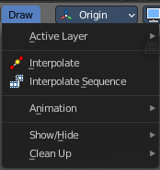

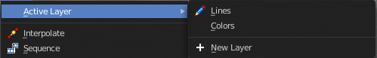
Active Layer
Set and show the active grease pencil layer. The layer with the pencil is the active layer for drawing.

New Layer
Add a new draw layer.

Interpolate
Interpolates strokes between the previous and next keyframe by adding a single keyframe. When you are on a frame between two keyframes and click the Interpolate button a new breakdown keyframe will be added. This way you define the final interpolation for the new stroke.

Interpolate Sequence
Interpolate strokes between the previous and next keyframe by adding multiple keyframes. When you are on a frame between two keyframes and click the sequence button, then a breakdown keyframe will be added on every frame between the previous and next keyframe.

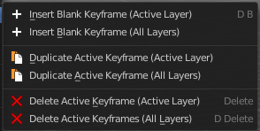
Animation

Insert Blank Keyframe ( Active Layer )
Inserts a keyframe into the active layer.

Insert Blank Keyframe ( All Layers )
Inserts a keyframe into all layers.

Last Operator Insert Blank Frame
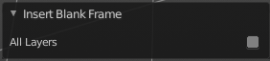
Some snap operations shows a last operation panel, some not.

All Layers
Insert into active layer or into all layers.

Duplicate Active Keyframe ( Active Layer )
Duplicates the active keyframe in the active layer.

Duplicate Active Keyframe ( All Layers )
Duplicates the active keyframe in all layers.

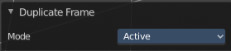
Last Operator Insert Blank Frame
Some snap operations shows a last operation panel, some not.

Mode
Duplicate the active keyframe in the active layer or in all layers.

Delete Active Keyframe ( Active Layer )
Deletes the active keyframe in the active layer.

Delete Active Keyframe ( All Layers )
Deletes the active keyframe in all layers

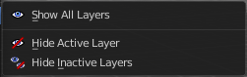
Show/Hide

Show all Layers
Makes all layers in the scene visible .

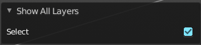
Last Operator Hide Layers

Select
Shows just selected layers.

Hide Active Layer
Hides the active layer.

Hide inactive Layers
Hides the not selected layers. The selected layers stays visible.

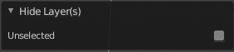
Last Operator Hide Layers

Unselected
Hides the not selected layers.

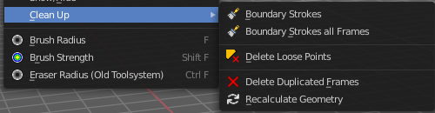
Clean Up

Boundary Strokes
Remove "no fill" boundary strokes from the active frame.

Boundary Strokes all Frames
Remove "no fill" boundary strokes from all frames.

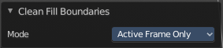
Last Operator Clean Fill Boundaries

Mode
Choose if you want to remove the "no fill" boundary strokes just from the active frame, or from all frames.

Delete loose Points
Deletes loose stroke points.

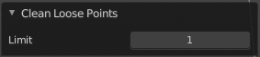
Last Operator Clean loose points

Limit
Adjust with how much vertices a stroke gets count as loose geometry.

Delete Duplicated Frames
Deletes all duplicated frames.

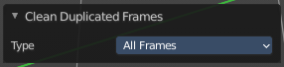
Last Operator Clean Duplicated Frames

Type
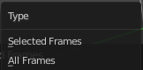
Delete just in the selected frames or in all frames.

Recalculate Geometry
Update all internal geometry data.

